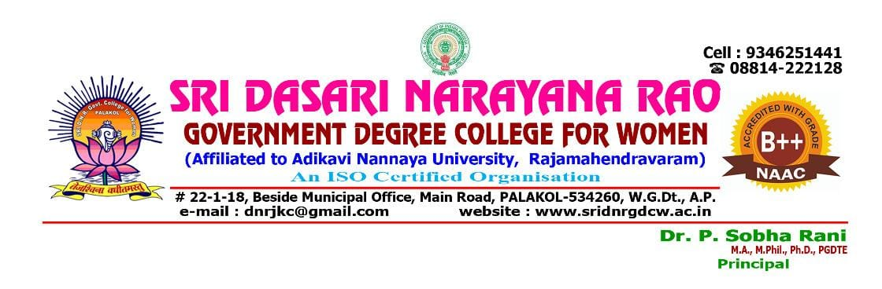
CIRCULAR
Allotment of students to the Concerned mentors for TWO Months Short term internship for the year 2024 – 25
NAME OF THE MENTOR | NAME OF THE STUDENTS | GROUP | COURSE NAME | SIGNATURE OF THE MENTOR
G. JYOTSNA RANI | DENABOINA BABY SINDHUJA | B.A | PHOTOSHOP
G. JYOTSNA RANI | GIDUGU LAKSHMITHA | B.A | PHOTOSHOP
G. JYOTSNA RANI | GUDURI SINDHU | B.A | PHOTOSHOP
G. JYOTSNA RANI | KADIMI BABY | B.A | PHOTOSHOP
G. JYOTSNA RANI | VANTAPATI SAI | B.A | PHOTOSHOP
G. JYOTSNA RANI | KUDIPUDI SANDHYANA | B.A | PHOTOSHOP
G. JYOTSNA RANI | LADDIKA RAMYA TEJASRI | B.A | PHOTOSHOP
K.M. MAHALAXMI | SHAIK SAI DURGA BHAVANI | B.A | PHOTOSHOP
K.M. MAHALAXMI | SIKHILE AKHILA | B.A | PHOTOSHOP
K.M. MAHALAXMI | MENDYALA LAVANYA | B.A | PHOTOSHOP
K.M. MAHALAXMI | POLAVARAPU JHANSI | B.A | PHOTOSHOP
K.M. MAHALAXMI | ROUTHU SAI SRAVANI | B.A | PHOTOSHOP
K.M. MAHALAXMI | SALA LAKSHMI DEVI | B.A | PHOTOSHOP
K.M. MAHALAXMI | SETTIM SANDHYA | B.A | PHOTOSHOP
C. RAVI SHANKAR | ADARI MANASA GANA DURGA KOMALI PARVATHI | B.COM | TALLY
C. RAVI SHANKAR | CHELLURI MADHAVI | B.COM | TALLY
C. RAVI SHANKAR | DUNABOINA JYOTHI | B.COM | TALLY
C. RAVI SHANKAR | GEDDAM BHANUMATHI | B.COM | TALLY
C. RAVI SHANKAR | GUBBALA SANDHYA | B.COM | TALLY
C. RAVI SHANKAR | GUBBALA YAMINI | B.COM | TALLY
C. RAVI SHANKAR | KOMBATTULA KAMALASRI | B.COM | TALLY
K. REVATHI SAI | KADIMI KEERTHANA | B.COM | TALLY
K. REVATHI SAI | KAMISETTI SWATHI | B.COM | TALLY
K. REVATHI SAI | KANKATALA KALYANI | B.COM | TALLY
K. REVATHI SAI | KAREPALLI SRAVANI | B.COM | TALLY
K. REVATHI SAI | KARNI KUSUMA | B.COM | TALLY
K. REVATHI SAI | KATTA NAVYA | B.COM | TALLY
K. REVATHI SAI | KOTI SIRISHA | B.COM | TALLY
I. BHAGYA LAKSHMI | MALLADI BABY | B.COM | TALLY
I. BHAGYA LAKSHMI | MOLLETI PHANINDRA LAKSHMI | B.COM | TALLY
I. BHAGYA LAKSHMI | PEDAPATI KIRANMAI | B.COM | TALLY
I. BHAGYA LAKSHMI | RAPAKA ARCHANA | B.COM | TALLY
I. BHAGYA LAKSHMI | RAPAKA SAILU | B.COM | TALLY
I. BHAGYA LAKSHMI | KOURU KOMALI | B.COM | TALLY
J. NOBLE JAWAHAR RAJ | REVULA SWETHANJALI DEVI | B.COM | TALLY
J. NOBLE JAWAHAR RAJ | SIDDANI MADHURI SAI VALLI | B.COM | TALLY
J. NOBLE JAWAHAR RAJ | SIRIGINEEDI REKHA | B.COM | TALLY
J. NOBLE JAWAHAR RAJ | SIRRA NARASAMMA | B.COM | TALLY
J. NOBLE JAWAHAR RAJ | KUDIPUDI TAVALI | B.COM | TALLY
L. RAMESH | TANETI BHAGYASRI | B.COM | TALLY
L. RAMESH | TENNETI SIRISHA | B.COM | TALLY
L. RAMESH | VADDI ANUSHA | B.COM | TALLY
L. RAMESH | YARRA VASAVI NAGA SRI VIJAYA LAKSHMI | B.COM | TALLY
L. RAMESH | KUKKALA VANITHA | B.COM | TALLY
G. SAILAJA | ABBISETTY GUNA PRIYA | M.P.Cs | PYTHON
G. SAILAJA | AYILA SANJANA | M.P.Cs | PYTHON
G. SAILAJA | BONAM DIVYA | M.P.Cs | PYTHON
G. SAILAJA | CHITTURI KALYANI | M.P.Cs | PYTHON
G. SAILAJA | DIGUMARTHI SRAVANTHI | M.P.Cs | PYTHON
Dr. A. SATYA NARAYANA | GEDDADA AISHWARYA | M.P.Cs | PYTHON
Dr. A. SATYA NARAYANA | GUDURI LAHARI | M.P.Cs | PYTHON
Dr. A. SATYA NARAYANA | KOLLE SHALINI | M.P.Cs | PYTHON
Dr. A. SATYA NARAYANA | KUPPALA NAGA SAI DURGA | M.P.Cs | PYTHON
Dr. A. SATYA NARAYANA | LAKKOJU BHAGYA SRAVANTHI SREE GAYATHRI | M.P.Cs | PYTHON
Dr. P. VENKATA RAMANA | MEESALA KEERTHI | M.P.Cs | PYTHON
Dr. P. VENKATA RAMANA | NILLA LAKSHMI | M.P.Cs | PYTHON
Dr. P. VENKATA RAMANA | PADUCHURI NAVYA | M.P.Cs | PYTHON
Dr. P. VENKATA RAMANA | POGIRI RENUKA DEVI | M.P.Cs | PYTHON
Dr. P. VENKATA RAMANA | POTHUMUDI RAJITHA | M.P.Cs | PYTHON
K. SREE PRASANNA | SIDDANI KESWARI | M.P.Cs | PYTHON
K. SREE PRASANNA | SRUNGAVRUKSHAM SUBHAGEETHA | M.P.Cs | PYTHON
K. SREE PRASANNA | TALLA NAGA MUTYALA VALLI | M.P.Cs | PYTHON
K. SREE PRASANNA | TANGETI PAVANI | M.P.Cs | PYTHON
K. SREE PRASANNA | VANKA TANUSHA | M.P.Cs | PYTHON
K. SREE PRASANNA | YALLAPU USHA SRI CHILUKULA NAGA DURGA | M.P.Cs | PYTHON
Dr. N. MANI MALA | ADIMULAM NEELIMA DEVI | Bi.Z.C | PHOTOSHOP
Dr. N. MANI MALA | BALLA NANDINI | Bi.Z.C | PHOTOSHOP
Dr. N. MANI MALA | CHINTHAPALLI NAVYASRI | Bi.Z.C | PHOTOSHOP
Dr. N. MANI MALA | CHODE PRASANNA LAKSHMI | Bi.Z.C | PHOTOSHOP
Dr. N. MANI MALA | EDI NAVYA SRI | Bi.Z.C | PHOTOSHOP
A. SREE SANDHYA | GEDDADA VIJAYA LAKSHMI | Bi.Z.C | PHOTOSHOP
A. SREE SANDHYA | GEDDAM RAJA KUMARI | Bi.Z.C | PHOTOSHOP
A. SREE SANDHYA | JUTTUGA MEGHANA MADHURI | Bi.Z.C | PHOTOSHOP
A. SREE SANDHYA | KODELA MOUNIKA RAMYA LAKSHMI | Bi.Z.C | PHOTOSHOP
A. SREE SANDHYA | POLUKONDA MAMATHA | Bi.Z.C | PHOTOSHOP
Dr. G. VIJAY SWAROOP SINGH | TADI SANTHI PRIYA | Bi.Z.C | PHOTOSHOP
Dr. G. VIJAY SWAROOP SINGH | TENNETI RANI | Bi.Z.C | PHOTOSHOP
Dr. G. VIJAY SWAROOP SINGH | VADAPALLI PEDDILA RANI | Bi.Z.C | PHOTOSHOP
Dr. G. VIJAY SWAROOP SINGH | VASKA RAMYA | Bi.Z.C | PHOTOSHOP
Dr. G. VIJAY SWAROOP SINGH | VETTI SARITHA | Bi.Z.C | PHOTOSHOP
Dr. G. VIJAY SWAROOP SINGH | YALLAPU GANGA NAGA PRAVEENA | Bi.Z.C | PHOTOSHOP

